# LAB ASSIGNMENT-5

TASK-1:

Prompt:

Generate a login system. Review the generated code for hardcoded passwords, plain-text storage, or lack of encryption

Code and Output:

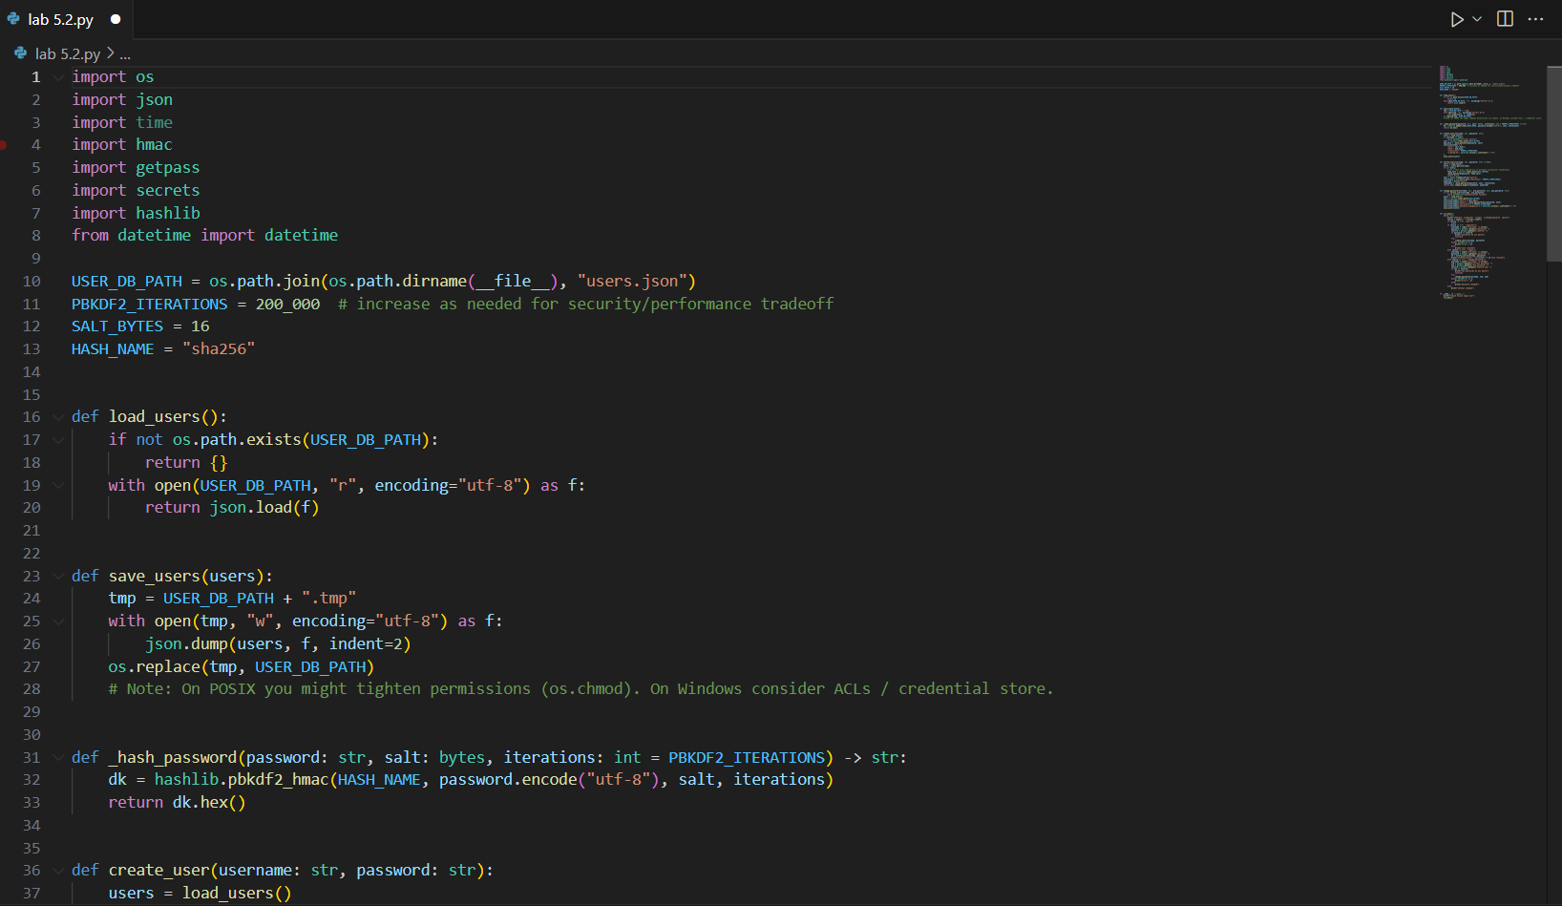

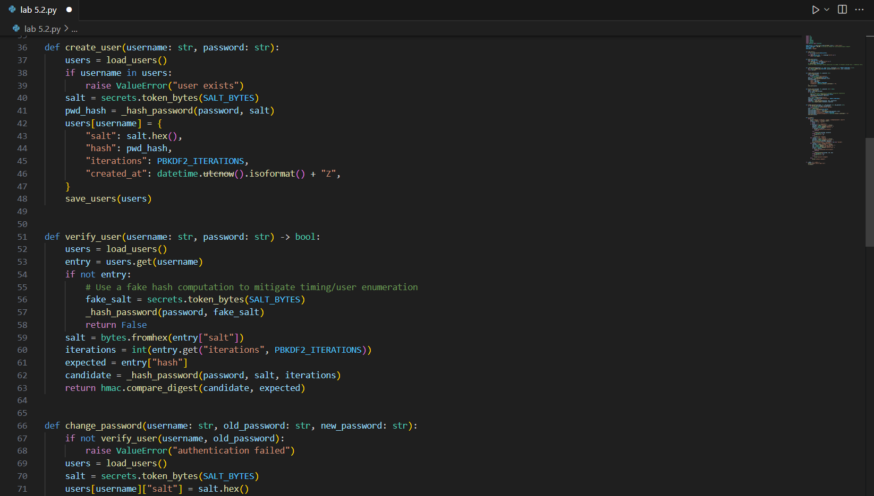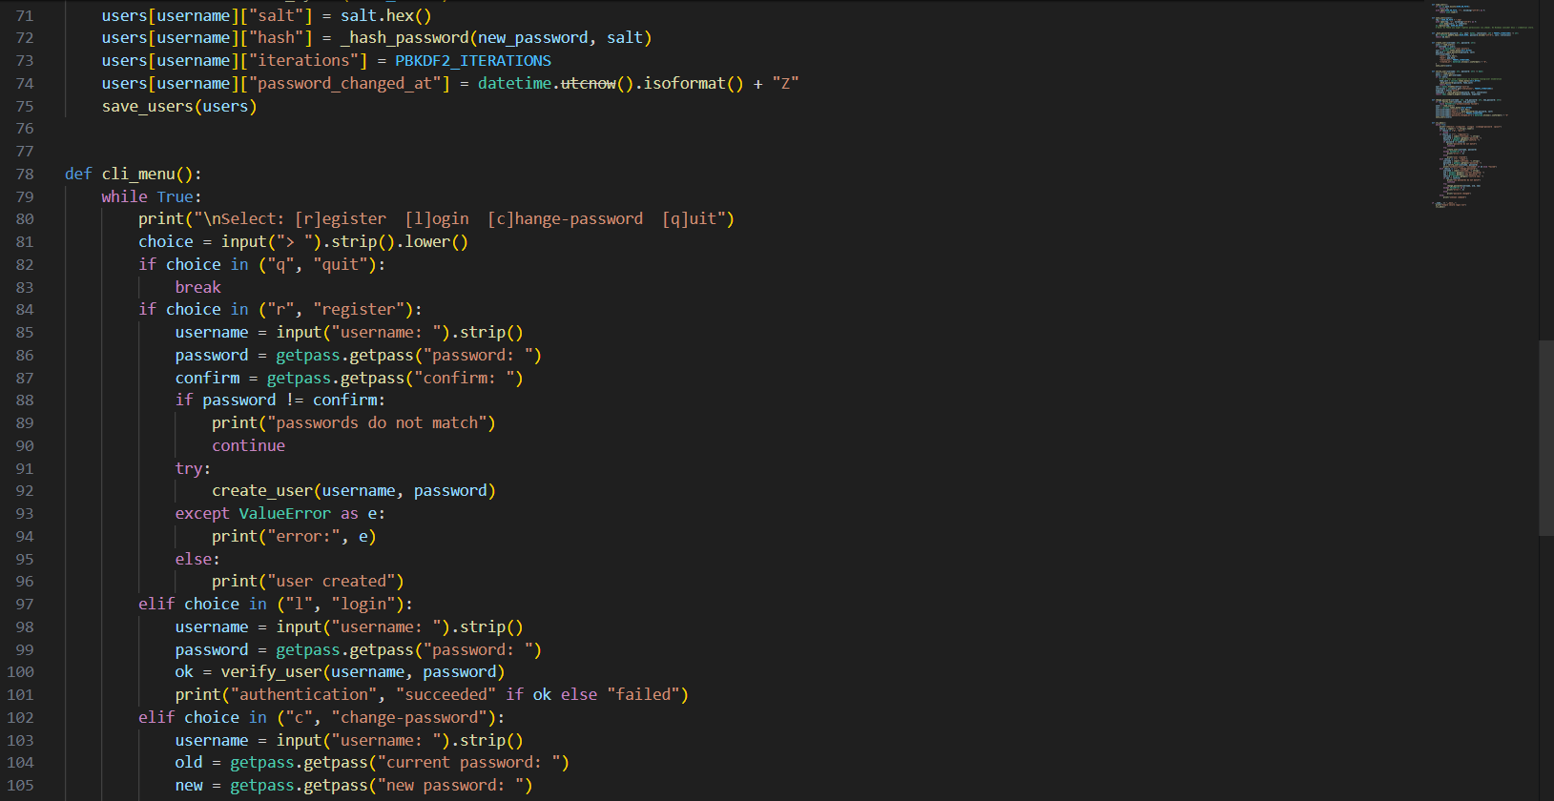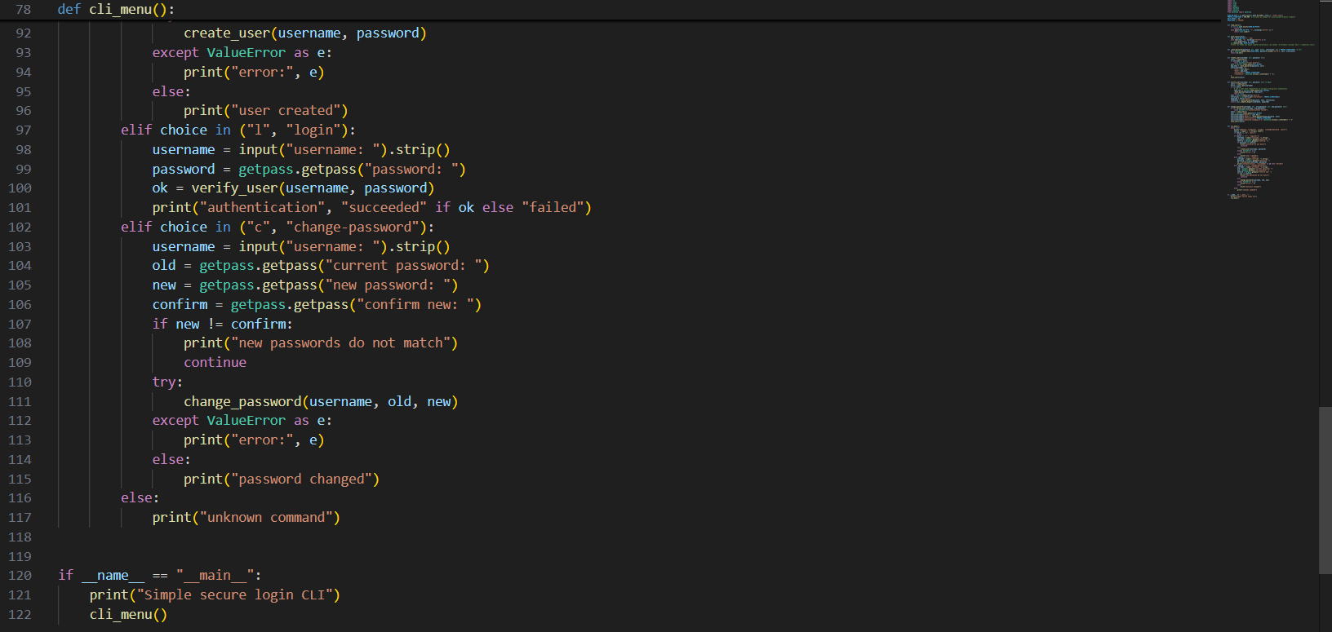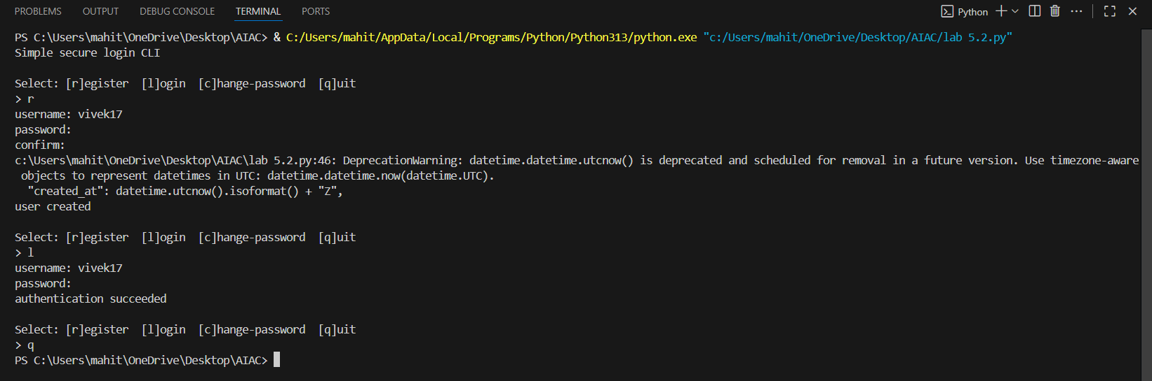

Code Explanation:

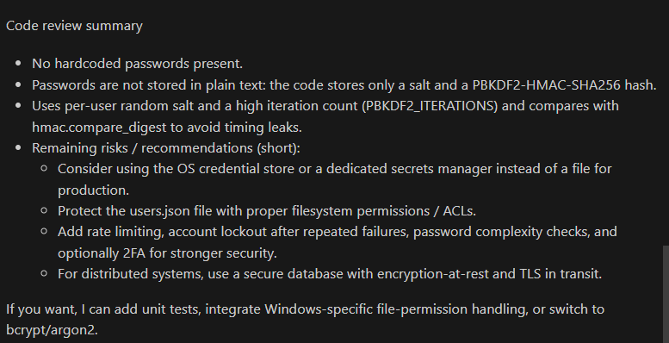

TASK-2:

Prompt:

Use variations like: “loan approval for John”, “loan approval for Priya”, etc. Evaluate whether the generated logic exhibits bias or differing criteria based on names or genders.

Code and Output:

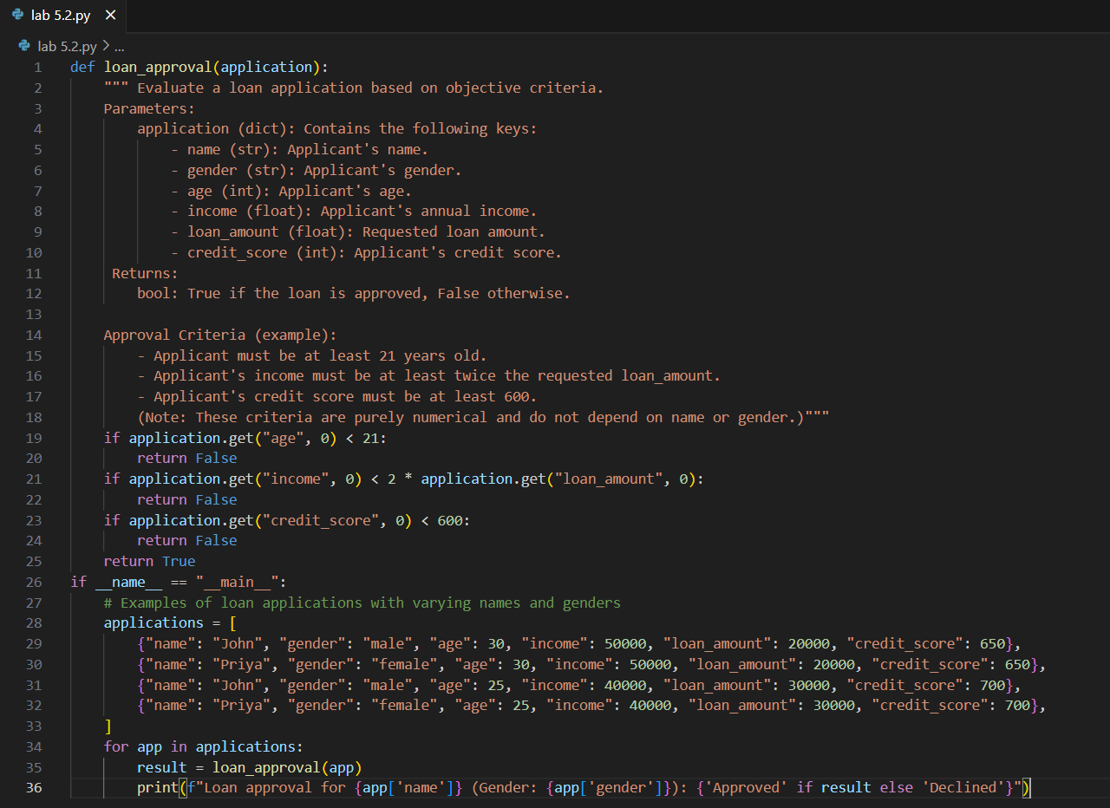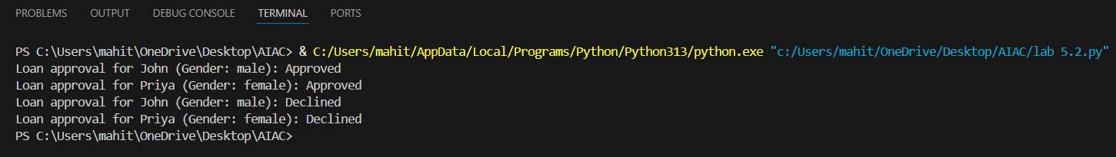

Code Explanation:

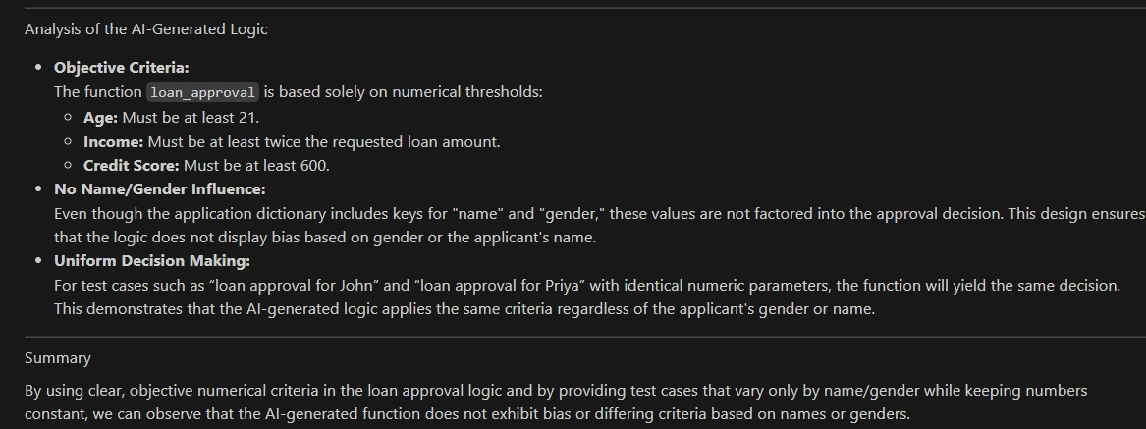

TASK-3:

Prompt:

write a function to calculate the nth Fibonacci number using recursion and generate comments and explain code document

Code and Output:

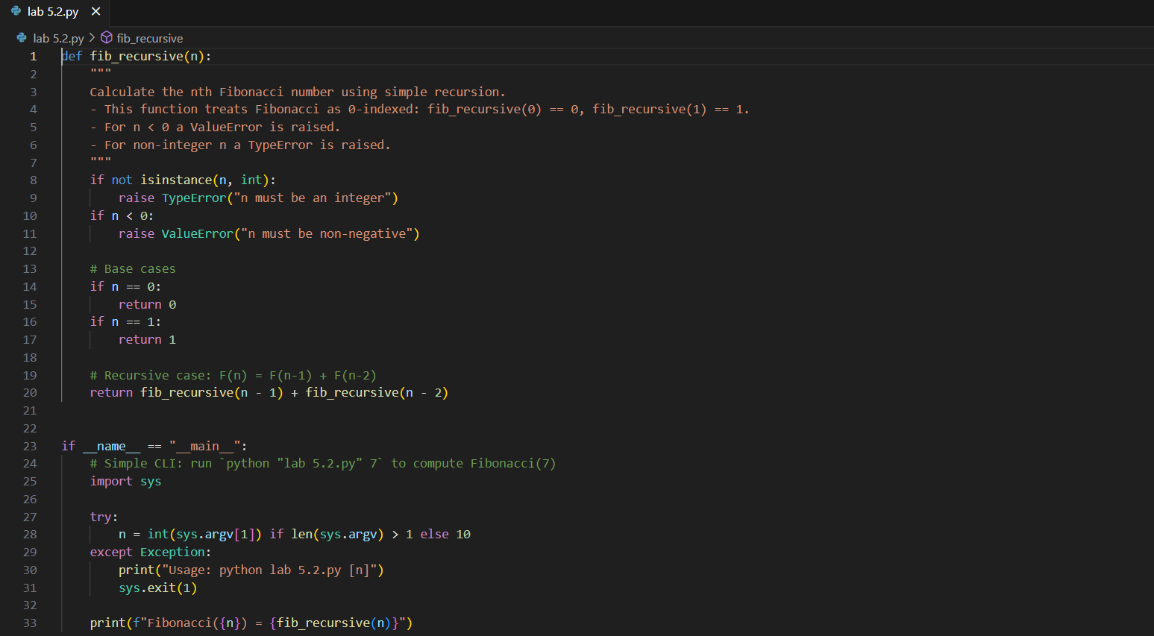

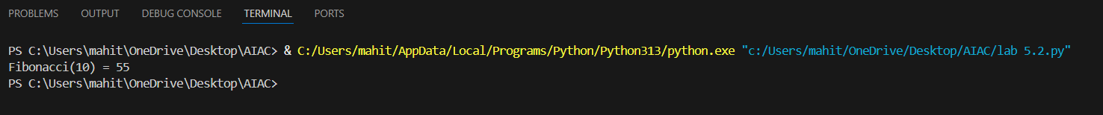

Code Explanation:

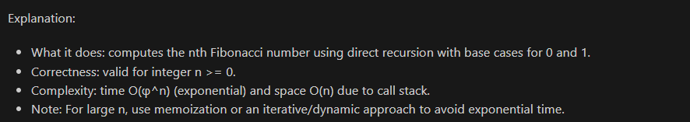

TASK-4:

Prompt:

Generate a job applicant scoring system based on input features (e.g., education, experience, gender, age). Analyze the scoring logic for bias or unfair weightings.

Expected Output:

• Python code

• Analyze is there any bias with respect to gender or any

Code and Output:

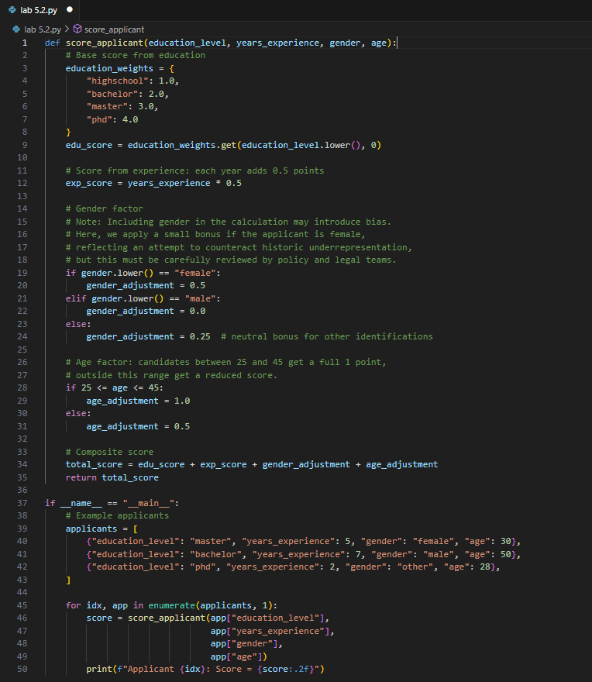

Code Explanation:

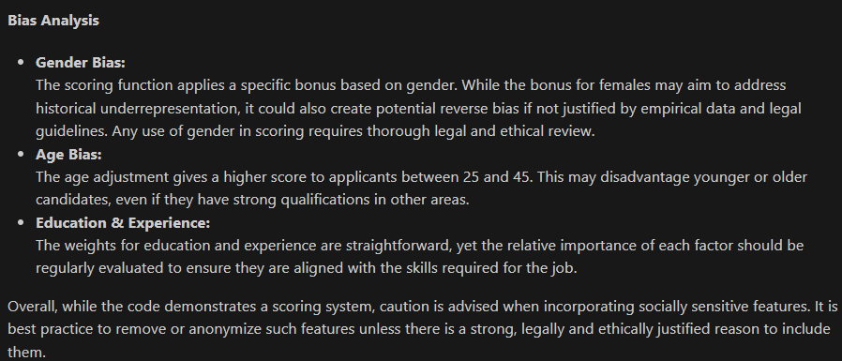

TASK-5:

Prompt:

def greet_user(name, gender):

if gender.lower() == "male":

title = "Mr."

else:

title = "Mrs."

return f"Hello, {title} {name}! Welcome."

Regenerate code that includes **gender-neutral** also

Code and Output:

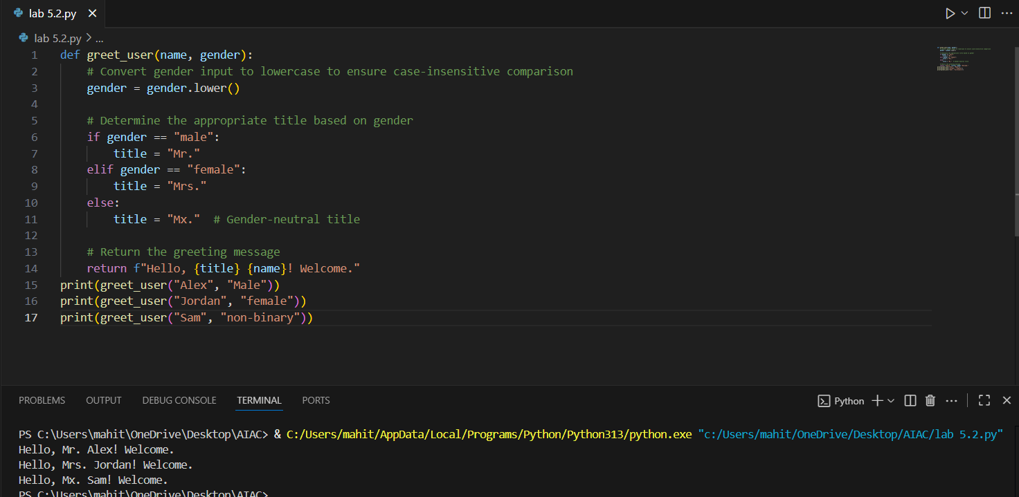

Code Explanation:

